For this assignment, you will consider some of the ethical and legal aspects of disaster management.
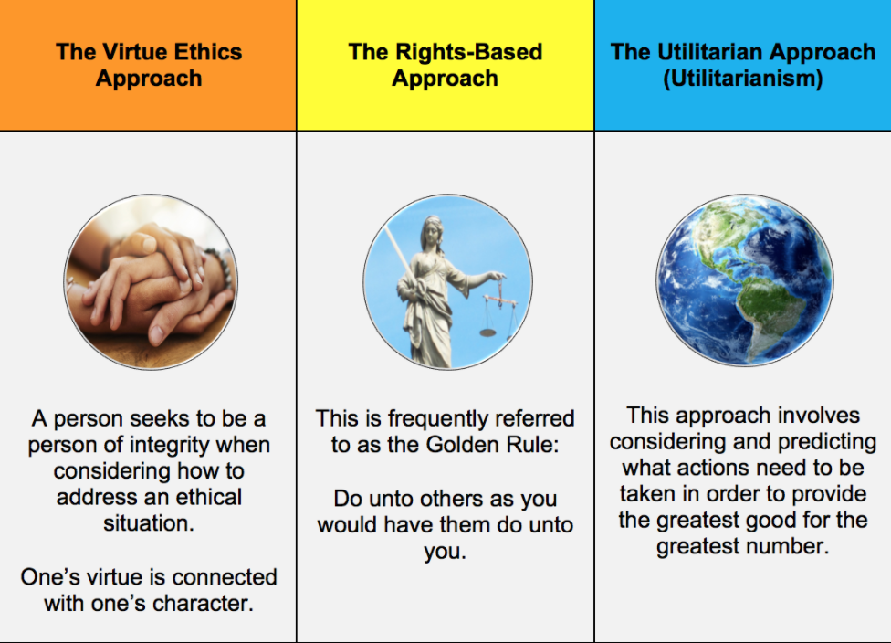

Use the assignment below to read and respond to for this week’s assignment.
Ethical Considerations During Disaster
^^^Click the link

Answer the following questions in a well-written paper:
- Which ethical approach do you think is the most useful for nurses when they plan for or deal with a natural disaster, and why did you select that approach?
- Discuss some ways nurses can prevent developing moral distress when their personal decision-making processes conflict with the processes that must be used during times of disaster.
- Discuss how the American Nurses Association (ANA) Code of Ethics provides guidance for nurses who respond to natural disaster.
American Nurses Association (ANA) Code of Ethics
^^^ click the link
• Your paper should be 2–3 pages in length, not including the title page and references page. Include an introduction and a conclusion to your paper.
• APA format! Plagiarism free!

Below you will find this assignments RUBRIC:
